Lab Report

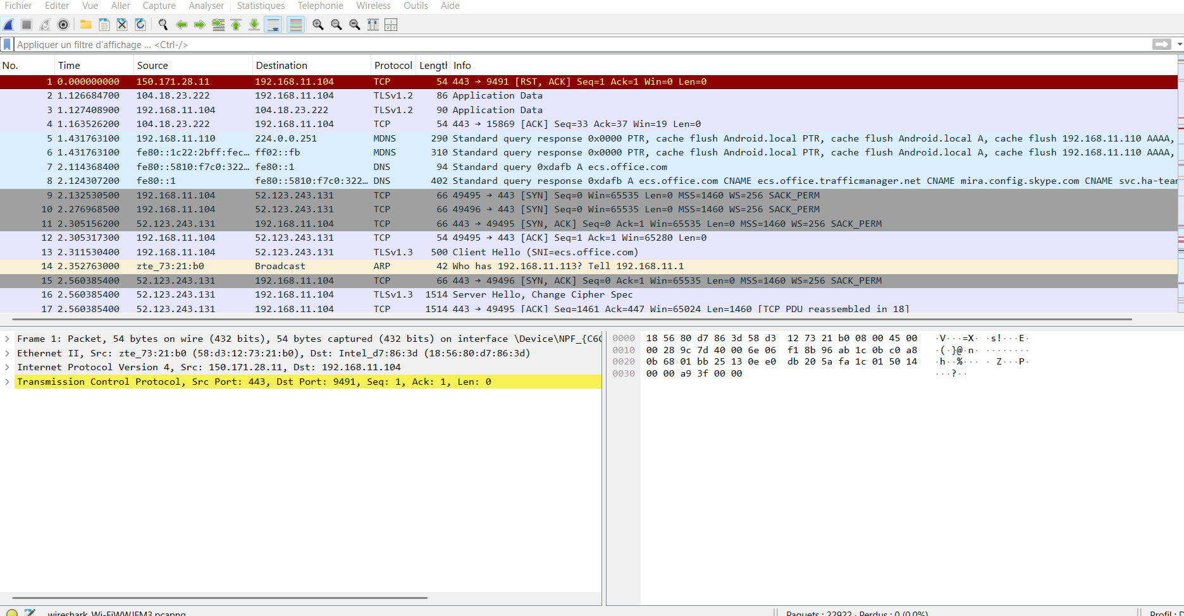
Interpretation of the Capture
- Visible Protocols: TCP, TLSv1.2, and DNS are observed.
- Packet Num 1: A TCP connection (port 443, which indicates HTTPS).
- Packet Num 3: A TLSv1.2 “Client Hello” packet, which represents the beginning of a secure communication.
- DNS Packets: They translate domain names into IP addresses.
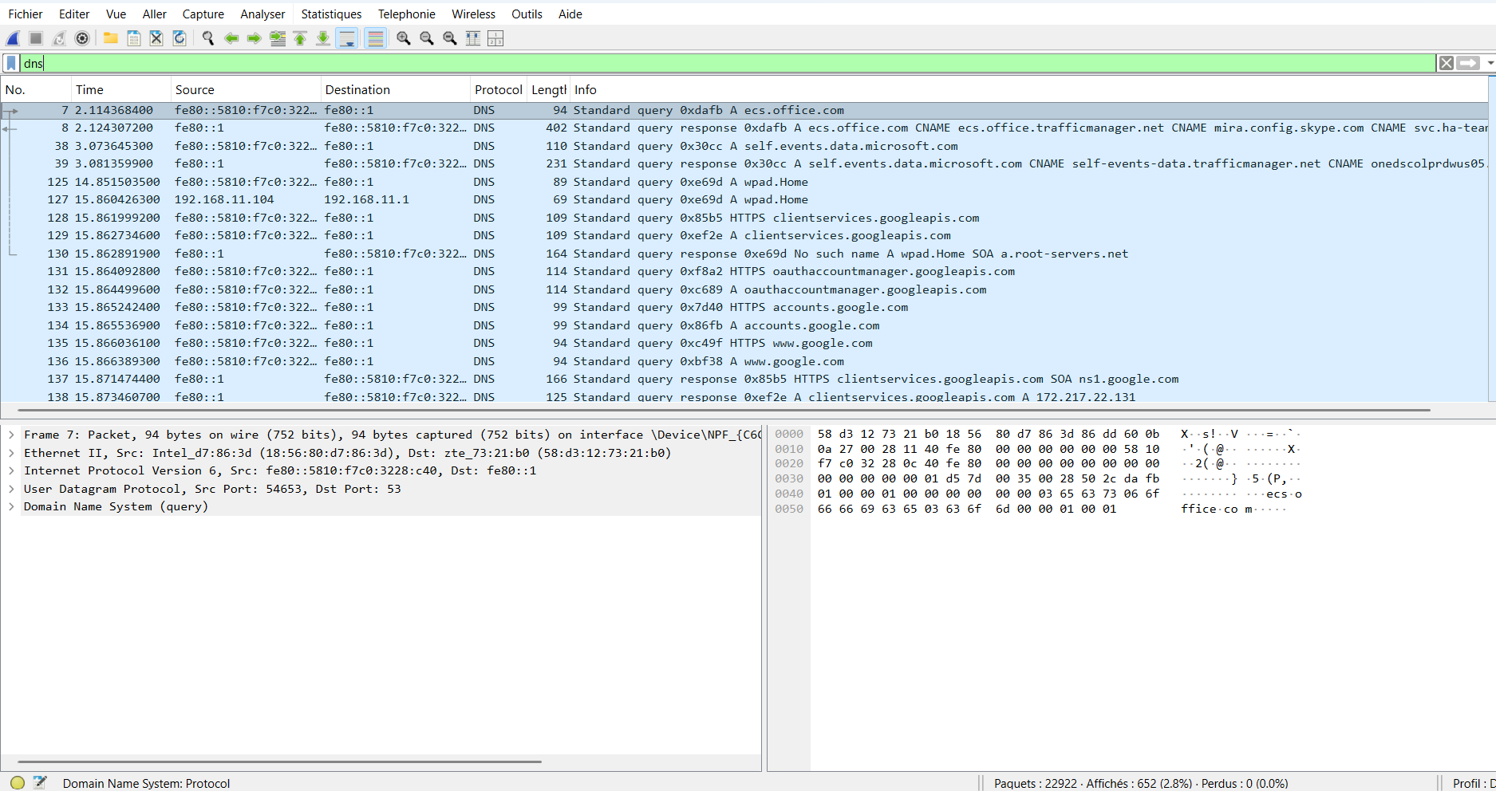
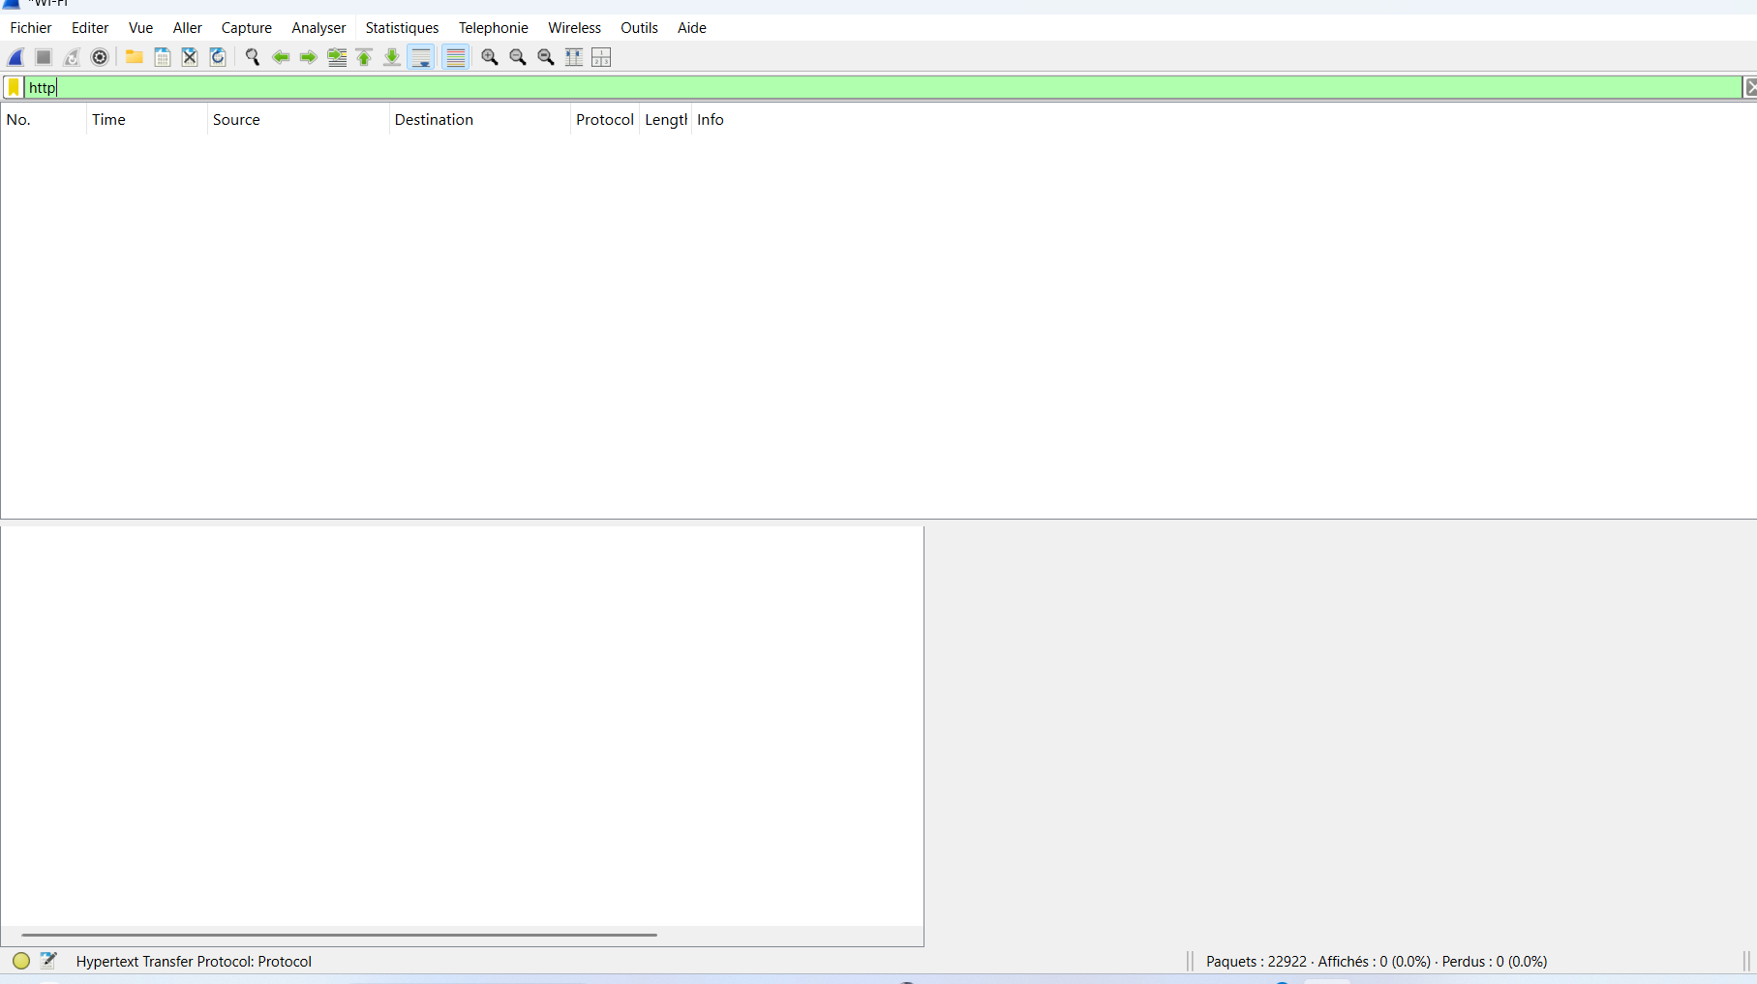
Interpretation of the Capture (HTTP Traffic)
- Number of packets captured: The status bar indicates 22.922 packets captured during the session.
- Highlighted protocol: At the bottom left, Wireshark shows Hypertext Transfer Protocol (HTTP).
- Observation: HTTP traffic is visible among the captured packets, which means some communications were not encrypted.

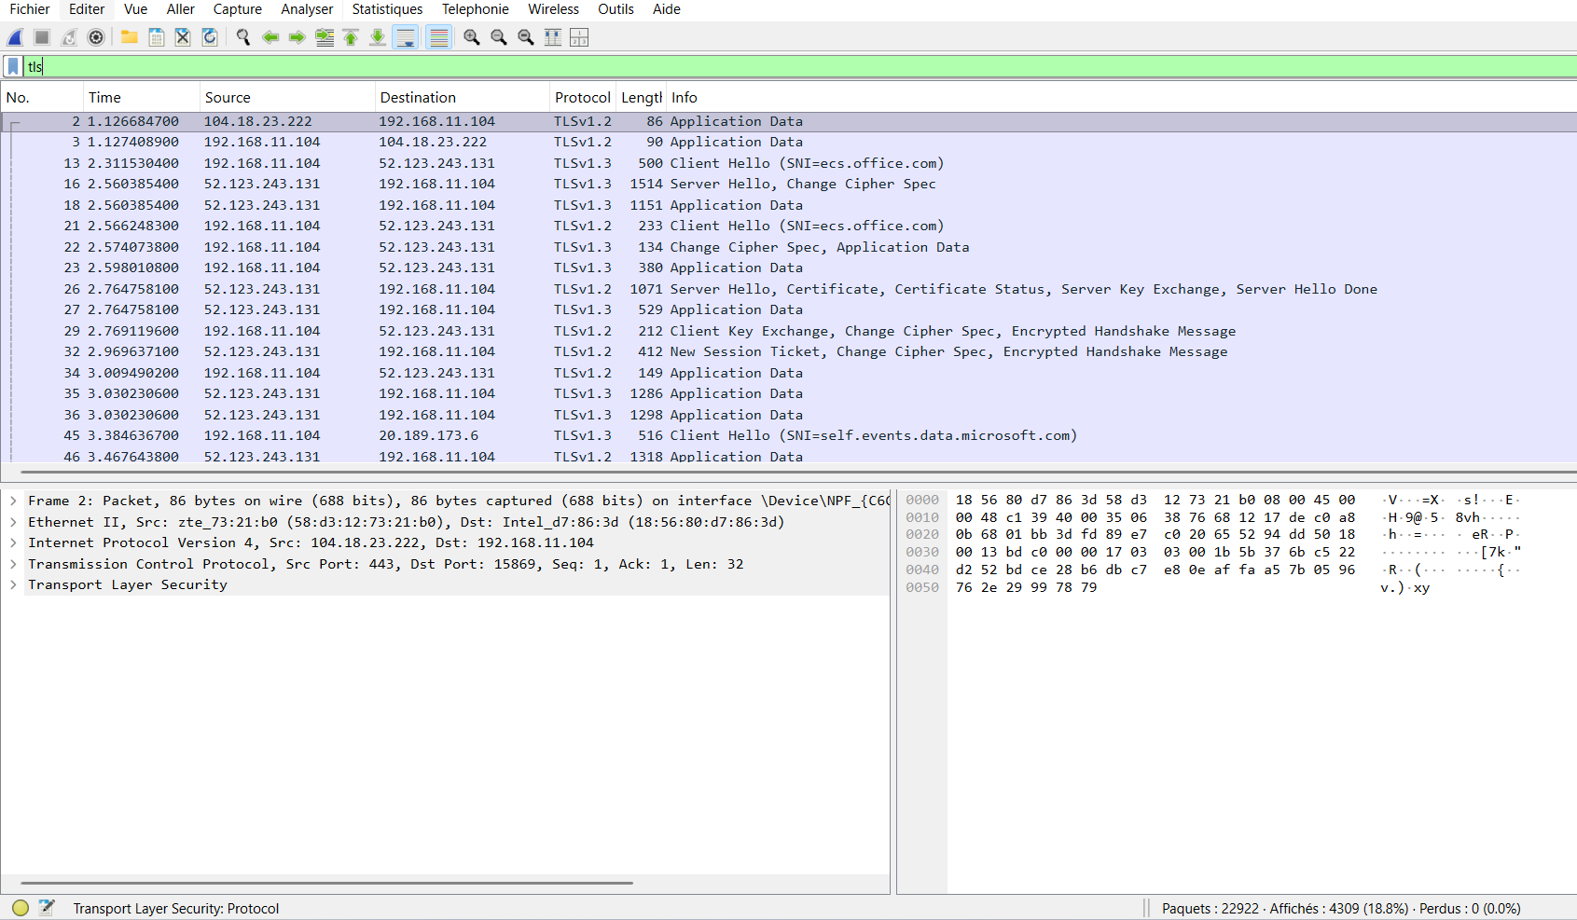
Results and Analysis :
During the experiment, Wireshark captured approximately 22,922 packets. The captured traffic revealed several key protocols, including TCP, TLSv1.2, DNS, and HTTP.
- TCP Traffic: TCP packets were observed establishing reliable communication between the client and servers. For example, connections on port 443 indicated the start of HTTPS sessions.
- TLS Traffic: TLSv1.2 packets such as Client Hello, Server Hello, and Certificate were captured. These represent the TLS handshake process, where encryption parameters are negotiated and secure communication is established.
- DNS Traffic: Multiple DNS queries and responses were recorded, including requests to root servers and queries for clients1.google.com. The DNS response resolved this domain to the IP address 172.217.23.206, showing how domain names are translated into IP addresses.
- HTTP Traffic: Some packets were identified as HTTP. Unlike HTTPS, HTTP transmits data in clear text, which exposes sensitive information to potential interception.
Importance of Encryption
Encryption is critical when browsing the internet because it ensures the confidentiality and integrity of transmitted data. The TLS handshake observed in the capture demonstrates how HTTPS protects sensitive information such as passwords, personal details, and financial data from attackers.
Risks of Unencrypted Traffic
Unencrypted traffic (such as HTTP or plain DNS) can reveal:
- The websites visited (via DNS queries).
- Exact URLs requested.
- Form data, login credentials, or cookies transmitted in clear text.
This highlights the importance of using strong encryption protocols like TLS/HTTPS to safeguard user privacy and security.

